ST. XAVIER’S COLLEGE

**(Affiliated to Tribhuvan University)**

**Maitighar, Kathmandu**



**Database Management Systems**

**Assignment #3**

**SUBMITTED BY:**

Victor Kumar Sapkota

013BSCCSIT047

**SUBMITTED TO**

|  |  |
| --- | --- |
| **Mr. Sanjay Kr. Yadav**  **( Lecturer )** |  |
| **Department of Computer Science** | |

**Database system components**

The basic database system components are shown in Fig. 1. They consist of:

* Data
* Hardware
* Software
* Users

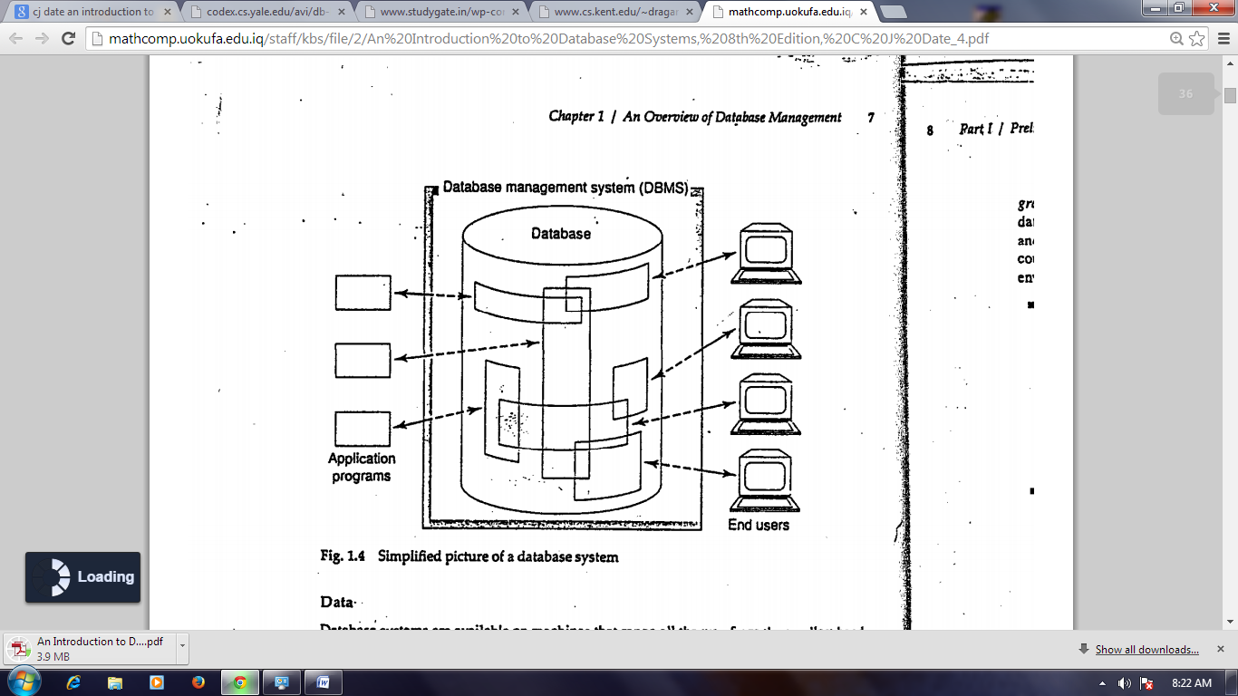

*Fig. 1: Database System Components*

**Data**

The data is stored in the database. Data in a database are both integrated and share.

* By integrated, we mean the database can be thought of as a unification of several otherwise distinct files, with any redundancy among those files partly or wholly eliminated.
* By shared, we mean the database can be shared among different users, in the sense that different users can have access to the same data, possibly even at the same time (“concurrent access”).

**Hardware**

The hardware components of the system consist of:

* The secondary storage volumes that are used to hold the stored data, together with the associated I/O devices, device controllers, I/O channels, and so forth
* The hardware processor(s) and associated main memory that are used to support the execution of the database system software

**Software**

Between the physical database itself and the users of the system is a layer of software, known most commonly as the database management system (DBMS). All requests for access to the database are handled by the DBMS. However, DBMS is not the only one software present in the system. Others include utilities, application development tools, design aids, report writers, and the transaction manger.

**Users**

There are three broad classes of users:

* First are the application programmers, responsible for writing database application programs in some programming language, such as COBOL, PL/I, C++, Java, or others.
* Next, there are end users, who access the database interactively.
* The last class of user, not illustrated in Fig. 1, is the database administrator or DBA.

**Data Communications Manager**

Database requests from an end user are actually transmitted from the user’s computer or workstation to the DBMS, in the form of communication messages. Likewise, responses back from the DBMS to the user’s workstation are also transmitted in the form of such messages. All such transmissions take place under the control of another software component, the data communications manager (DC Manager). The DC manager is not part of the DBMS but is an autonomous system in its own right. However, it is clear that it requires to work in harmony with the DBMS.

**Utilities**

Utilities are programs designed to help the DBA with various administrative tasks. Some examples of the kind of utilities that are typically needed in practice:

* Load routines
* Unload/reload routines
* Reorganization routines
* Statistical routines
* Analysis routines

**Variation of Distributed Environments**

Three variations are shown in Figs. 2, 3, and 4 respectively:

* Client and server running on different machines
* One server machine, many client machines
* Each machine runs both client(s) and server

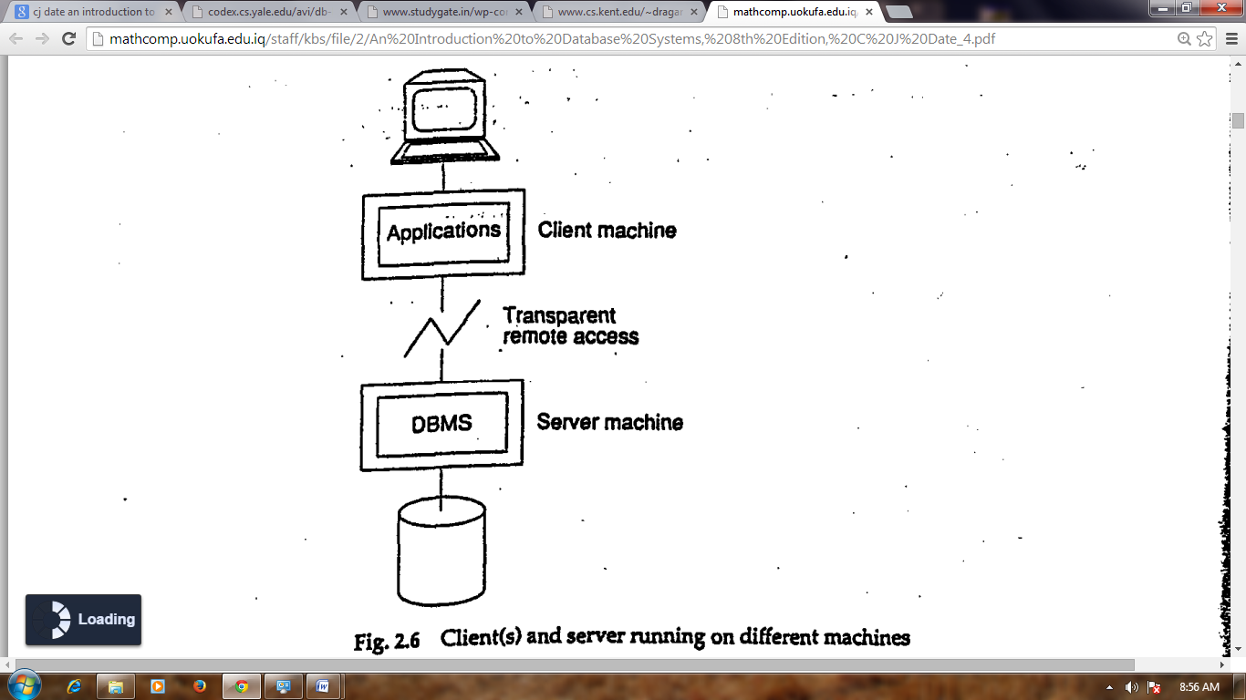

*Fig. 2: Client and server running on different machines*

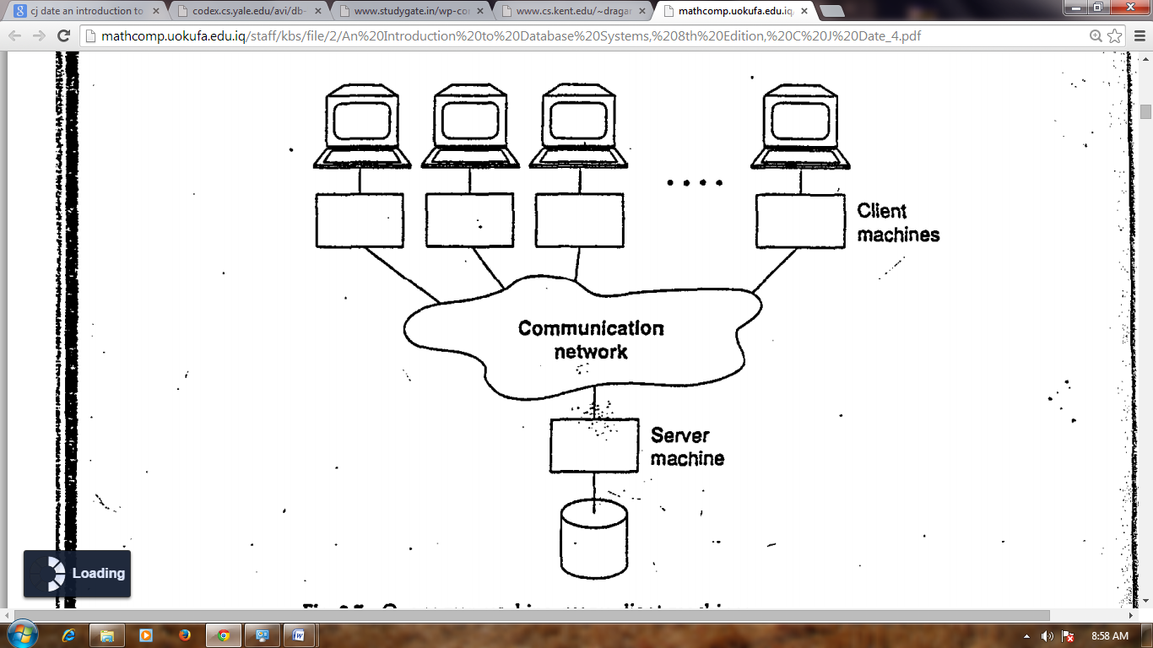

*Fig. 3: One server machine, many client machines*

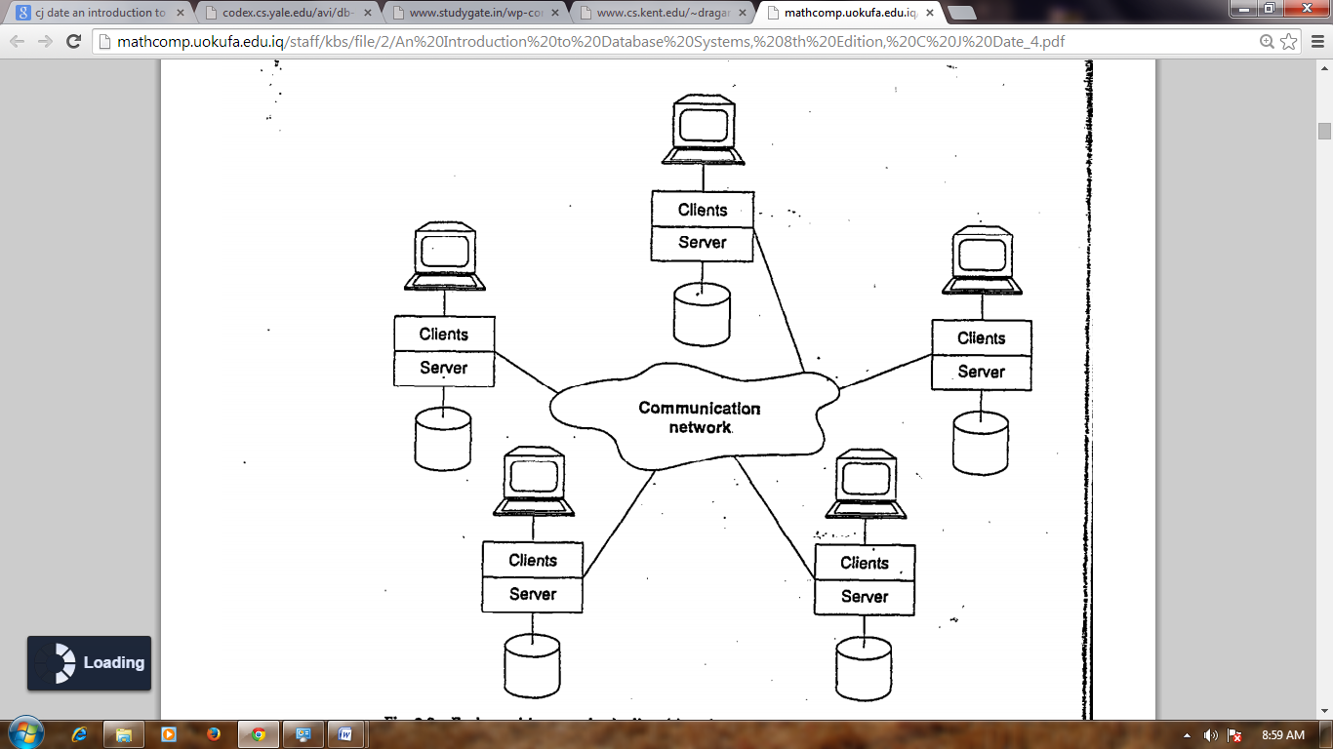

*Fig. 4: Each machine runs both client(s) and server*